Which of the following would give benzyl chloride
A. Toulene reaction with chlorine in the presence of sunlight
B. Benzyl chloride with chlorine in the presence of sunlight
C. Benzal chloride with chlorine
D. All of these
ANSWER: A
Which of the following is meta director?
A. $-NO_{2}$
B. $-CH_{3}$
C. $-OH$
D. $-NH_{2}$
ANSWER: A
Which of the following reacts with $HNO_{3}$ $(H_{2}SO_{4})$gives nitration reaction at maximum rate?
A. 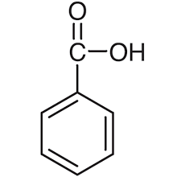
B. 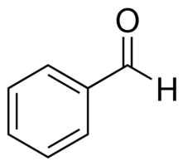
C. 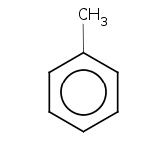
D. 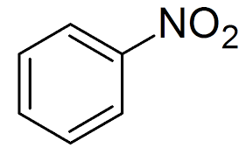
ANSWER: C
In which of the following reactions, the by product is HX?
A. Halogenation
B. Alkylation
C. Acylation
D. All of these
ANSWER: D

In which of the following electrophilic substitution reactions, water maybe the by-product?
A. Nitration
B. Alkylation
C. Acylation
D. Halogenation
ANSWER: A
In which of the following $NO_{2}^{+}$ is electrophile?
A. Nitration
B. Sulphonation
C. Alkylation
D. Halogenation
ANSWER: A
On electrophilic substitution of benzene_____ product is formed.
A. Monosubstituted
B. Disubstituted
C. Trisubstituted
D. All of these
ANSWER: A
The group that leaves on electrophilic substitution of benzene is _____
A. Carbon
B. Hydrogen
C. Carbon and hydrogen
D. None of these
ANSWER: B
Sulphonation means
A. Addition of $SO_{4}$
B. Addition of $SO_{2}$
C. Addition of $SO_{3}$
D. Addition of $H_{2}SO_{4}$
ANSWER: C
Which of the following catalysts are used in alkylation or acylation?
A. $AlX_{3}$
B. $H_{2}SO_{4}$
C. $FeX_{3}$
D. None of these
ANSWER: A
The catalyst used in halogenation of benzene is ____.
A. $AlX_{3}$
B. $H_{2}SO_{4}$
C. $FeX_{3}$
D. None of these
ANSWER: C
Which of the following is not Lewis acid?
A. $AlBr_{3}$
B. $H_{2}SO_{4}$
C. $FeCl_{3}$
D. $H_{2}O$
ANSWER: B
Alkyl benzene will form when benzene undergo_____.
A. Nitration
B. Sulphonation
C. Alkylation
D. Halogenation
ANSWER: C
Which of the following substitution reactions take place in benzene?
A. Free radical
B. Electrophilic substitution reaction
C. Nucleophilic substitution reaction
D. All of these
ANSWER: B
It activates the benzene ring.
A. Electron withdrawing deactivating group
B. Electron donating activating groups.
C. Electron donating deactivating group
D. Electron withdrawing activating group
ANSWER: C

